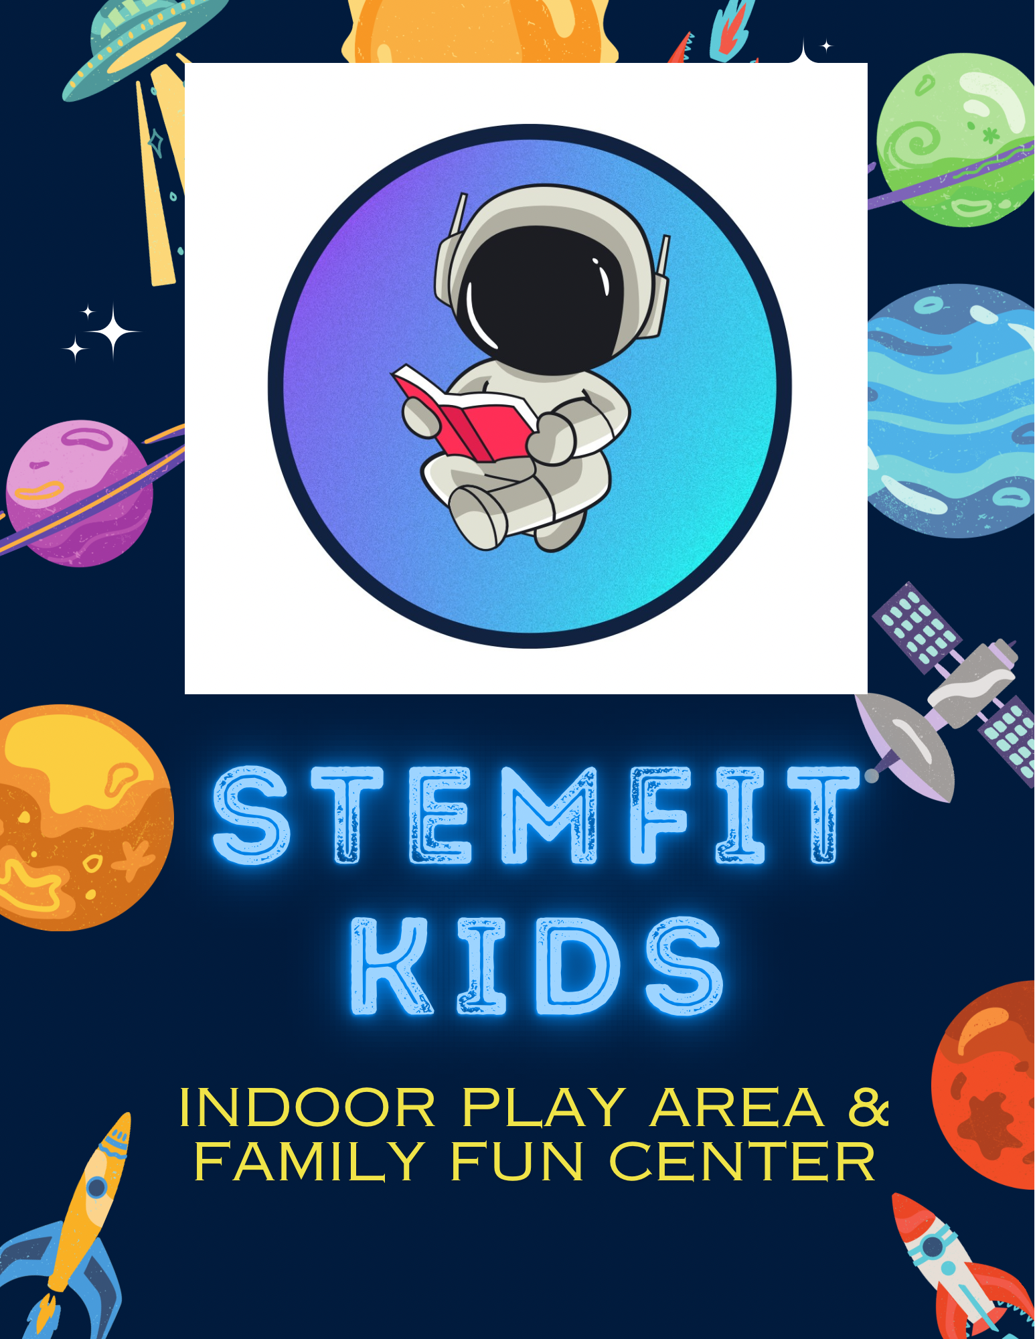
Summer Camp Parental Agreement
This contract is between, Stemfit Kids a Little Scholars EDU program, and
____________________
____________________________________ for the care of:
(Parents or Guardian)
NAME:________________________________________ BIRTHDATE: ____________
NAME:________________________________________ BIRTHDATE: ____________
NAME:________________________________________ BIRTHDATE: ____________
Childcare will begin on ____________________, 2026
PARENT(S) NAME(S):
______________________________________________________________ PARENT
ADDRESS:_________________________________________________________
_____
__________________________________________________________________ ______
HOME TELEPHONE NUMBER:__________________________________ MOTHER’S WORK NUMBER:___________________________________

MOTHER’S CELL NUMBER: ____________________________________
FATHER’S WORK NUMBER:____________________________________ FATHER’S CELL NUMBER: _____________________________________ E-MAIL ADDRESS FOR DAYCARE RELATED CORRESPONDENCE:
__________________________________________________________________ _____
Contracted days and hours:
*7:00am-5:30pm
________________________________________________
The fee for Summer Camp will be _____________ per week.
PARENT SIGNATURE: _________________________________________
PARENT SIGNATURE: _________________________________________ PROVIDER SIGNATURE: _______________________________________ DATE SIGNED: ____________________

